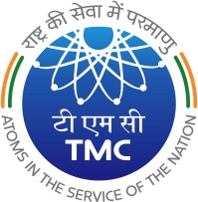
TATA MEMORIAL CENTRE TATA MEMORIAL HOSPITAL
(A Grant-in Aid Institute under Dept. of Atomic Energy, Govt. of India) DR. E. BORGES MARG,

PAREL, MUMBAI 400 012

09.07.2024

CPP Tender Notice 34: Corrigendum – II

CPP TENDER ID - 2024_TMC_809692_1

Sub: Corrigendum – II for CPP tender Notice No. 34 for supply of “Liquid Handling System for NGS”, Qty. 1 no. for Molecular Pathology Department, TMH.

Sr.  No. | Item Description | Original |  | Corrigendum- I | Corrigendum - II
 |  | Last date of Tender  submission | Tender Opening | Rescheduled pre-bid meeting from 10.06.2024  to 13.06.2024 | Last date of Tender  Submission | Tender Opening
1 | Liquid Handling System for  NGS | 18.07.2024  up to 03.00 pm | 19.07.2024  at 03.30 pm onwards |  | 25.07.2024  up to 03.00 pm | 26.07.2024 at  03.30 pm onwards
 |  |  |  |  | Revised technical specification after pre-bid uploaded on CPP Portal.

For more details, kindly visit the web site - https://eprocure.gov.in/eprocure/app

PURCHASE OFFICER

